Reduction of Outages in Transmission Using Real-Time Technique
Dr. Ugwu George (Ph.D)
Department of Electrical and Electronic Engineering, Faculty of Engineering
Enugu State University of Science and Technology (ESUT), Enugu

Publication Process | Date
Accepted | October 28th, 2021
Published | October 31st, 2021

ABSTRACT
Availability of power supply and steady electric power to the users is vital to the growth of any economy to achieve its maximum benefits. In Nigeria, the country faces a serious challenge in terms of power supply. This is caused by low power generation as a result of vandalism of power facilities by dubious people and by other factors like aging of power facilities, overloading transformers, etc. The main problem is that little generated power is not properly managed. The allocated megawatts by different load centers (substations) are being consumed above the allocated megawatts. That is to say that the consumed megawatts exceed the allocated megawatts due to the higher demand for power. This situation gives birth to emergency load shedding. So, the problem is how do we reduce this emergency load shedding in transmission lines? The real-time technique was used to examine and adopted to reduce emergency load shedding in the transmission line. The real-time technique is a system, that allocates load or megawatts to maintain, allocate sheet for hourly reading, monitor load, raise alarm if the consumption exceeds the load allocations, and control or isolate substation that exceeded load allocation. The following were done: Collation of transmissions line outages data, Application of real-time techniques to Transmission line Network, simulate results using MATLAB. Hypertext processor (PHP) software was used to write a program that monitors and controls load allocation. The real-time technique was introduced using General Cotton Mill (GCM) 132kV substation as a test system, and the result shows that the real-time technique reduces emergency load shedding by 0.1892%. The work shows the result of the real-time technique and how such a technique can be extended to the entire grid to reduce emergency load shedding.
Keywords: Reduction, Outages, Transmission, Real-time, Technique, Power

1. Introduction
In Nigeria, power plays a very important role in driving the economy. In agriculture, power plays a role in seedling planting, and irrigation of farmland. In the education sector, research and sectaries of the school coin easy savor as a result of steady power supply. In manufacturing industries, that is where the impact of steady power is well felt. The heavy machine is driven by a constant power supply. Governments also enjoy their series of meetings and activities of the day as a result of a steady power supply. Consumers are not left behind as they enjoyed cheap products as a result of the constant power supply. But lack of power or lack of steady power supply or at least 12 hours steady supply in Nigeria had posed a serious threat to all sections of the economy. For instance, in the education sector, lack of a steady power supply had delayed researches, prices of commodities and services had gone up and no remedy had been done to salvage the situation.
In a hospital, the same menaces of frequent outages are also experienced there. The money hospital spent on diesel to power their generator is unbearable, which is not also clean and carbon iv oxide generator release is hazardous to human health. The Hospital that is supposed to be a relief to the patient now turns to be a threat to the patient due to the nature of some hospitals and where the generator is located. The annoying part is that the patients bear the pain accrued from the cost of powering their generator set. In manufacturing industries is where the impact of power outage is experienced most. Due to constant emergency load shedding and sometimes system collapse, manufacturing industries find it difficult to produce their product. For instance, in polythene small scale industries, popularly known as waterproof or leather or nylon. They use an extruder to melt the polythene but due to constant emergency load shedding they cannot afford a big generator to power the cutting machine but the small generator cannot power the extruder as a result of this, their business lead to a queuing system when the supply came and within some hours they enter emergency load shedding. Generally, power outages had affected the manufacturing industry in terms of emergency load shedding. Lying off workers due to the high cost of production and low turnover as a result of an increase in the prices of commodities.
Reducing power outages in Nigeria will be a welcome development to address the difficulties government, residential occupants, manufacturing, hospitals, school, and agricultural sectors experienced. That is the motive of this research work.
What is a power outage? Power outage is the temporal or permanent drop or cutoff of power from the source to the receiving end. There are different types of outages based on the report gathered from TCN operators and from their logbook which is stated below.
Plan outage: this is kind of outage occurs when there is maintenance work. It can be as a result of topping oil in the transformer, recasting of cable or conductors, replacing outdated panels, etc.
Load shedding: this kind of outage occurred as a result of the drop in the generator, which led the system operator to shed load in order to maintain the load that will not cause problems to the system, or leads to force outage or system failure.
Force outage: this kind of outage occurred as a result of a fault on the line. This takes place when vegetation touches the line, it leads to earth fault when two lines meet each other which lead to over current faults, in a case the distribution company doesn’t have good protection system because of windy condition, it trips and inter trip the transmission 132KVbreaker. Another form of force outage is when the generated load is not used, which causes the 330KV line to be in a very high voltage and trip the line on high voltage.
Emergency load shedding: this occurred when the consumed megawatts exceeded allocated megawatts.
In the past, many techniques, tools, and methods were employed to reduce outage in the transmission line which includes clearing the right of way, that is clearing vegetation, using modern protection systems, using fuzzy logic and artificial neural network as a tool to reduce outage, increasing the generating capacity to meet the growing demand, forecasting, that is using a mathematical formula to calculating the anticipated load for an area in the future, but as it stands today, the rate of outage, especially load shedding is alarming. This study proposes a real-time technique to reduce emergency load shedding in the transmission line.

2. Method
Real-time Design
A real-time system is a system in which the functioning of the system, the timing of the system, and the result produced by the system are the same.
The design was done as a written program that can allocate load, control, and isolate the system when a particular substation exceeded its load allocation.
Sensor
Real-time control system
Actuator
Actuator
Circuit breaker panel

Figure 1: Real-time Block Model
Sensor: responsible for checking the input signal
Actuator: It is the interface between the panel and the system
Real-time control system: it is responsible for making a decision based on the command it receives.
Control systems
There is an interface between the system and the ammeters, which when the consumed megawatts exceeded the allocated megawatts, the system will switch the substation OFF and send them a message that they are out, but if they are within their allocated megawatts, the system allows them to be ON.
Controls systems are in response to sensor values through their actuators, which send signals to the control system to take action based on the command it receives.
3. Mathematical relationship of real-time techniques
Real-time is a written program using Php software, the mathematical relationship of the program is shown below
$power\left(P\right)= VICosθ$…………………………………………..(1)
Where
P = power
V= voltage
I = current
Cos$θ=phasor angle$
Using power loss equation
${P=I}^{2}R$ …………………………………………………………(2)
Where
P = Power
$$I^{2}=curent$$
R= resistance
Let R = $ϵ$…………………………………………………………(3)
Where $ϵ$ is the comparator that compares where the to consume load is exceed the allocated load
We now have
${P=I}^{2}ϵ$ …………………………………………………………(4)
S0, $ϵ$ determine whether there will be power or not
So, let $ϵ_{o}$ indicate when the consumed load exceed the allocated loads, which made $ϵ$ to isolate the substation automatically, we have
${P=I}^{2}ϵ_{0}$ …………………………………………………………(5)
Let $ϵ_{0}=0$
We have
$${P=I}^{2}× 0$$
P = 0
Then Let $ϵ_{1}$indicate when the consumed load is equal or below the allocated load, which made $ϵ_{1}$ to allow current flow to the substation automatically, we have
$${P=I}^{2}ϵ_{1}$$
Let $ϵ_{1}=1$
We have
$${P=I}^{2}× 1$$
${P=I}^{2}ϵ_{1}$ desired.
The PHP Control Model
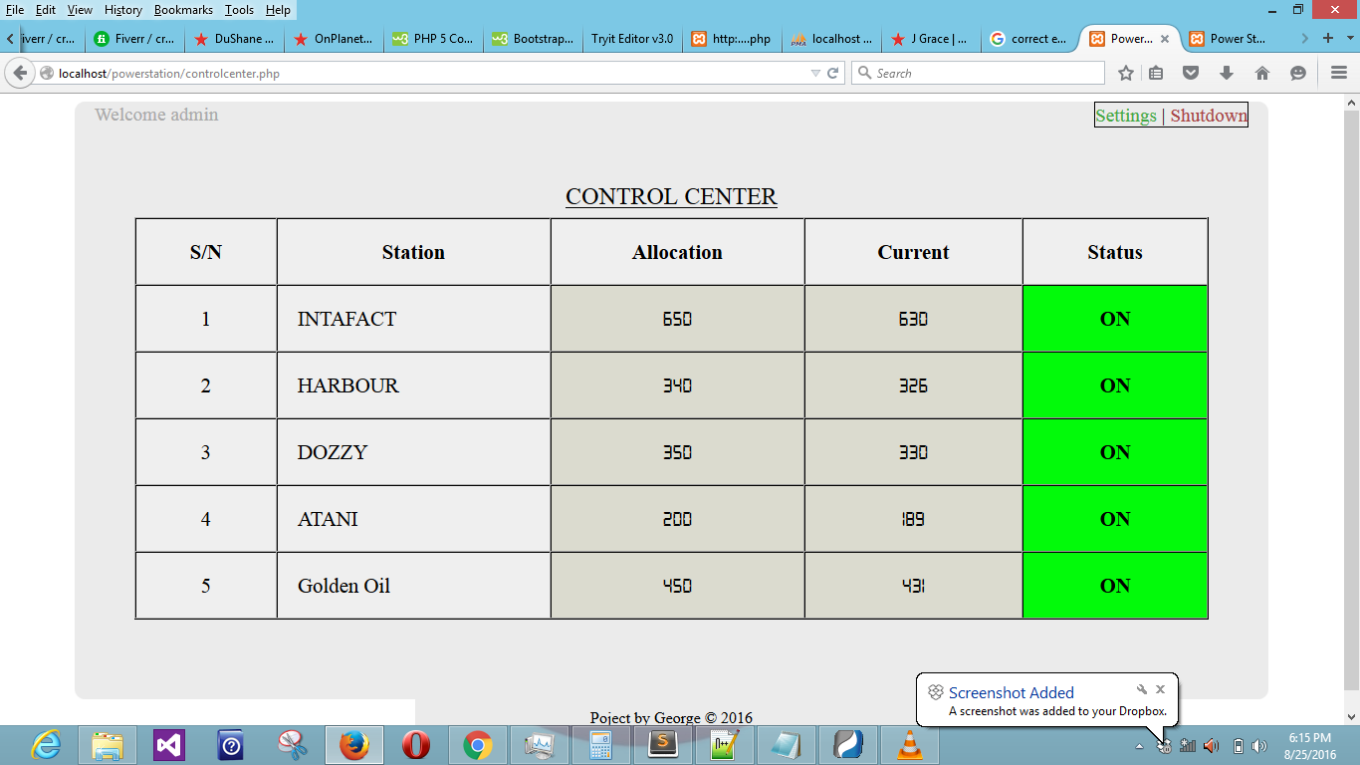Figure 2: The PHP control model
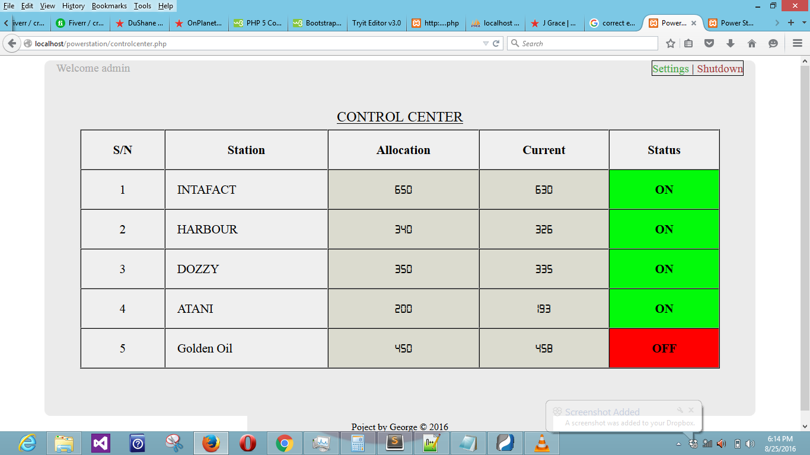
Figure 3: The PHP control model
The figures above show the control model of PHP, the name of the substations, load allocation, load consumption, and the PHP controllers which isolate the substation that exceeded their load consumption automatically and send a signal off to them, that they are OFF. But if the substation maintains its load allocation, the PHP controller allows them to be ON.
4. Application of Real-time Technique to Transmission Network
Real-time Technique is a written program that will monitor megawatts per hour to reduce emergency load shedding or ensure that the consumed megawatts did not exceed the allocated megawatts. The first page of the real-time program development is the username and password and login. The user will put his or her user name and password and click login. The next page is the Admin and sign-in. Admin only accessed by the administrator, the administrator clicks the admin menu, the next step is the username, password, and login, the administrator queue in his or her username and password and then, click log in.
The next page is
1. log out
2. Home
3. Allocate load to feeders
4. Open feeders reading.
If the administrator wants to log out, he clicks on log out. If he wants to go back, he clicks on home. If he wants to allocate the load to feeders, he clicks on to allocate the load to feeders. If he wants to view the reading, he clicks on open feeders readings.
Sign In: After the admin, the next menu is sign-in. If the different substation wants to know the megawatts allocated to them and queue in their readings, they will click on sign in, queue in their user name and password and click log in. the next thing you will see is
1. Log out
2. Add consumption
3. View
4. View mail
If their want to log out, they click on log out, if their want to queue in their readings, they click on consumption. To view their reading, they click on view, to see their mail if they exceed the megawatts allocated to them, click on view mail. This technique is real-time, as any substation is queuing in; others are seeing their reading at this time.
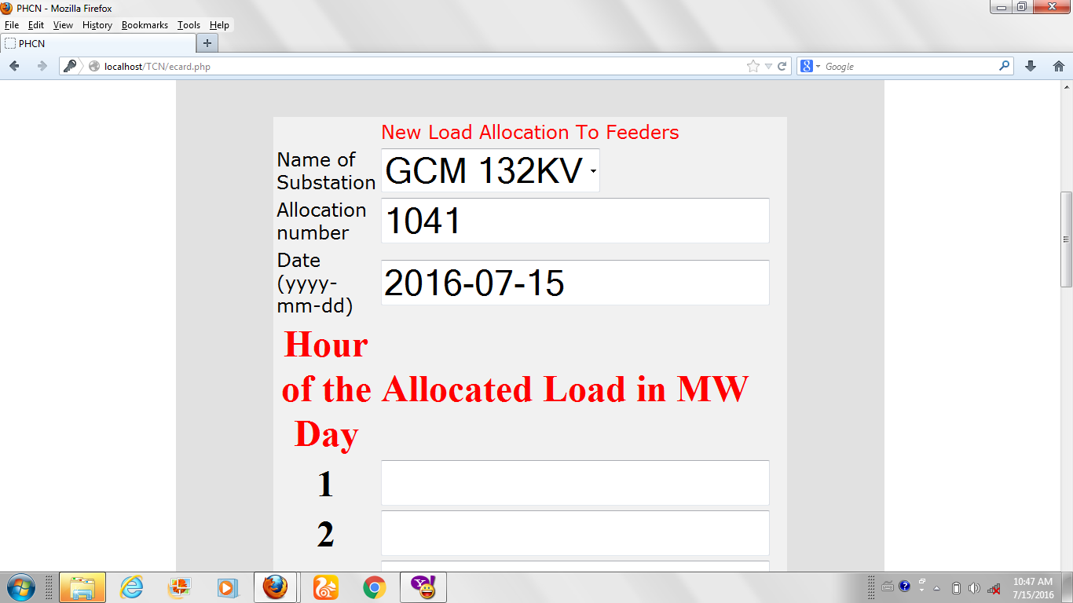
Figure 4: Allocated Load in MW Per Day

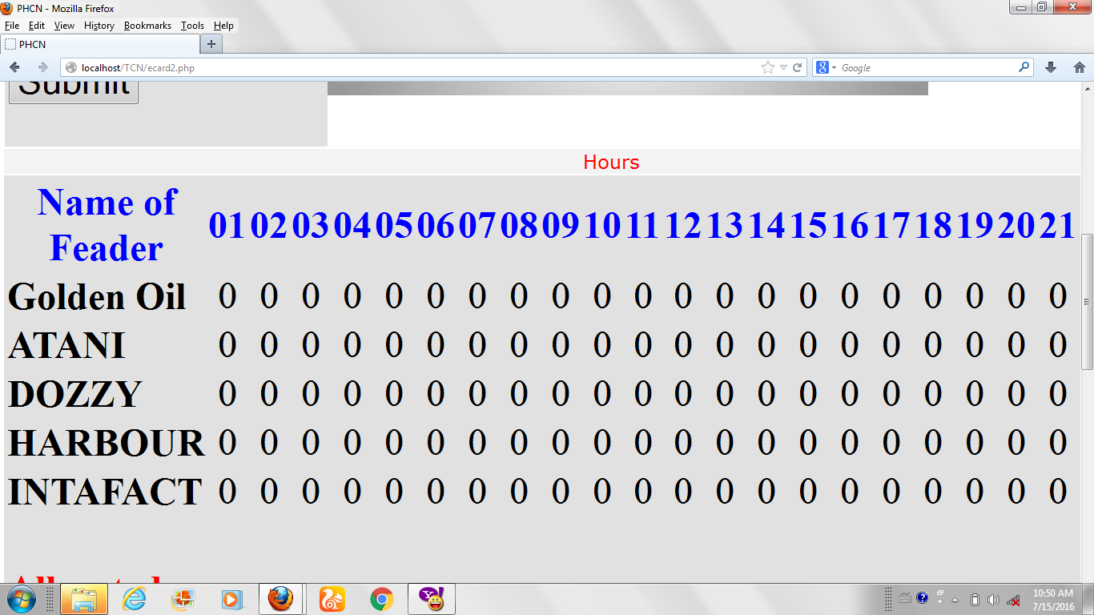
Figure 5: Real-time reading per day
The system is designed with the interface between the ammeter which switch OFF and ON button to access when each substation exceeded their load allocation and automatically switch off the defaulter substation.
This technique was incorporated using General Cotton Mill (GCM)132KV, as a test system.
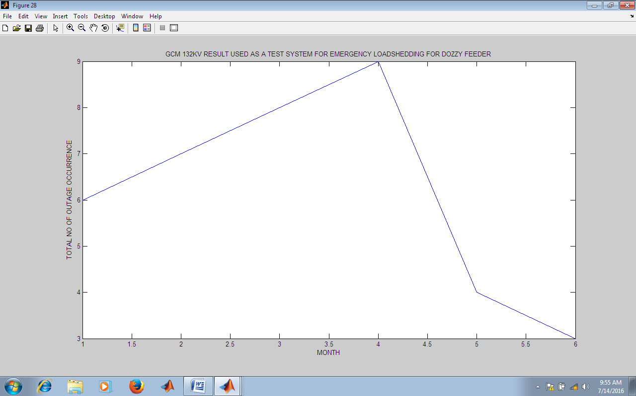
Figure 6: Emergency load shedding without incorporation Real-time Technique

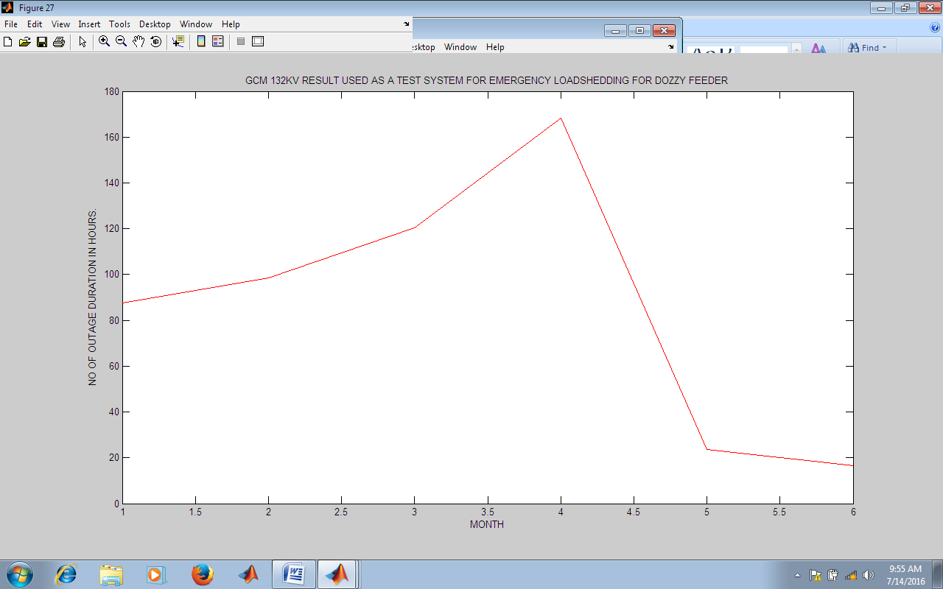
Figure 7: Emergency load shedding with Incorporation of Real-time technique

5. Conclusion
In the graph, 1 represents January, 2 represents February, 3 represents March, 4 represents April, 5 represents May while 6 represents June, month are presented with numbers ranging from 1 to 6 as explained and their meaning above, these number on months are plotted at the horizontal axis, while the numbers of outage occurrence are plotted on the vertical axis, as we can see from these graph, we have more outage occurrences ranging from January, February March, April, May, and June for plan outage, force outage, load shedding and emergency load shedding, but when the real-time technique was introduced in May and June, we can see that outage occurrence reduce for Dozzy feeder, harbor feeder, Atani feeder, Golden oil feeder, and Intafact feeder in terms of emergency load shedding.

References
Abdu Abdulahi, (2013). Enugu Electricity Distribution Company Protection Seminar, Volume 2,
Adachi F: (1993). Post detection Optimal Diversity Combiner for DPSK Differential Detection. IEEE Transactions on Vehicular Technology, Volume 42.
Alan Burns and Andy Wellings (2009). Real-time systems and programming language (4th ed).
Ben-An M., (1990). Principles of Concurrent and Distributed Programming, Prentice-Hall. 16: 164. ISBN 0-13-7 11821-X.
Bouthiba T. (2004). Fault location in EHV Transmission lines using artificial neural networks. International Journal of Applied Mathematics and Computer Science, 14(1): 69-78.
Bruce F And Allen J.W (2006). Power Generation, Operation, and Control. John Wiley And Sons Inc, Second Edition Page 44-64.
Buttazzo, Giogio (2011). Hard Real-time computing systems predictable scheduling algorithm and applications New York NY Springer.
Chen Z. and Maun J.C.,(2000). Artificial Neural Network approach to single-ended fault locator for transmission lines, IEEE Trans. on Power Systems, 15(1): 170-175.
Couch, L. W.,(1993). Analog Communication Systems, 4th edition, Macmillan, New York.
Coury D. V., Oleskovicz M. and Aggarwal R. K. (2002). An ANN routine for fault detection, classification and location in transmission lines, Electrical Power Components and Systems, 30(11): 1137-1149.
Ganiya A. Ajenikoho, (2015) ‘A Model For Assessment of Power System Outage on Nigeria Transmission Network, International Journal of Engineering Science, 4: 73-80.
Hong, Chan, Chin, (2003). Fault Diagnosis Of Power System Using Fuzzy Logic. IEEE Trans Power System, Volume 18.
John Stankovic (1988). Misconceptions about real-time computing: a serious problem for next-generation systems. Computer IEEE Computer Society, 21(10): 11.
Krishna Kant (2010). Computer-Based industrial control books Google. Com PHI Learning. P. 356. Retrieved, 01-17.
Kuo, S.M. LEE B.H and Tain, W. (2006). Real-time digital signal processing: implementation and application”. ISBN -470-01495-4 section 1.3.4: Real-time constraints.
L .S., (2002). Power Distribution Imbalanced Using Fuzzy Classification Algorithm, IEEE, 22: 30-40.
Liu C. and J. Layland (1973). Scheduling Algorithms for multiprogramming in a Hard Real-time environment. Journal of the ACM. 20(1): 46-61.
Liu, Jane W.S (2000). Real-time systems, upper Saddule River. NJ: Prentice-Hall.
Martin, James (1965). Programming Real-time computer system Englewood, Cliffs. N.J: Prentice-Hall; Inc. p.4 ISBN 013-730507-9.
Onohaobi O. Sunday, (2009) Research Journal Of Applied Science, 4:1-9.
Rappaport T.S. (2002). Wireless Communication Principles and Practice 2nd edition Singapore: Pearson Education, Inc.
Sara Kudrle et al (2011). Fingerprinting for solving A/V synchronization issues within Broadcast environments. Motion Imaging Journal.
Shin, K.G, Ramanathan, P. (1994). Real-time computing: a new discipline of computer science and engineering. Proceedings of the IEEE, 82(1): 6-24.
Sklar Bernard, (2002). Digital Communications: Fundaments and Application. Prentice-Hall, 2nd Editions, 30-33.

